**A**

**CASE STUDY REPORT ON**

# “Connected Vehicles: IoT and Vehicles-To-Everything(V2X)Communication”

Submitted by:

Meet Munda 2124UDSM2044 Om Thorat 2124UDSM2057 Chetan Gade 2124UDSM2085 Jagdish Malkar 2124UDSM2004

Under Guidance of :

Dr. Kiran Wakchaure



**DEPARTMENT**

**ARTIFICIAL INTELLIGENCE & DATA SCIENCE SANJIVANI UNIVERSITY**

**School of Engineering & Technology (SET)**

**2024-25**

**DEPARTMENT**

**ARTIFICIAL INTELLIGENCE & DATA SCIENCE SANJIVANI UNIVERSITY**

**School of Engineering & Technology (SET)**



# CERTIFICATE

This is to certify that the seminar report entitled

# “Connected Vehicles: IoT and Vehicles-To-Everything(V2X)Communication”

Submitted by :

**Meet Munda 2124UDSM2044,Om Thorat 2124UDSM2057, Chetan Gade 2124UDSM2085, Jagdish Malkar 2124UDSM2004** is a record of bonafide work carried out by her under the supervision and guidance of **Dr. Kiran Wakchaure** in partial fulfillment of the requirement for **Second Year (AIDS)** of School of Engineering & Technology, Sanjivani University in the academic year 2024-2025.

Date:

Place: Kopargaon

## Dr. Kiran Wakchaure Dr. K. Vengatesan Dr. Kavitha Rani

(Project Guide) (Head of Department) (Dean, SET SU)

## ACKNOWLEDGMENT

I would like to thank **Dr. Kiran Wakchaure**, my report guide, for his constant guidance, support, and motivation throughout this work. His helpful suggestions, clear feedback, and patience helped me solve problems and complete this report successfully. His advice has not only improved my knowledge but also inspired me to learn more. I am very grateful to **Prof. K. Vengatesan**, Head of the Department, for his strong support and leadership. His focus on academic excellence and new ideas gave me the resources and encouragement I needed to finish this report. His belief in my abilities has been a big source of motivation.

I also want to thank **Dr. Kavitha Rani**, Dean of Sanjivani University, for her great leadership and for creating a learning environment that supports growth and research. Her steady support and kind words have been important in completing this report.

Finally, I would like to thank all the faculty members and my peers for their valuable advice and teamwork, which made this journey worthwhile. Their help has improved the quality of this report. Without the support of these respected individuals, this report would not have been possible. I am truly thankful for their help and encouragement at every step of my work.

**Meet Munda 2124UDSM2044**

**Om Thorat 2124UDSM2057 Chetan Gade 2124UDSM2085 Jagdish Malkar 2124UDSM2004**

**CONTENTS**

1. Introduction 1
2. Iot in Smart Metering 1
3. Benefits of Iot in Smart Metering 2
4. Impact of IoT in Daily Life 3
5. Challenges and Considerations 3
6. Future of Smart Metering 3
7. Conclusion 4
8. References 5

**Abstract**

The rapid evolution of automotive technologies has given rise to connected vehicles, a transformative innovation

that integrates Internet of Things (IoT) systems with vehicular networks to enhance road safety, traffic efficiency

, and driving experience. At the heart of this advancement lies Vehicles-to-Everything (V2X) communication—a comprehensive communication framework enabling vehicles to interact with various entities including other

vehicles (V2V), infrastructure (V2I), pedestrians (V2P), networks (V2N), and the cloud (V2C). This report

explores the synergistic relationship between IoT and V2X technologies, examining how they collectively

enable real-time data exchange, predictive analytics, and autonomous decision-making.

The integration of IoT sensors and devices in vehicles allows for continuous monitoring of environmental

conditions, vehicular performance, and driver behavior. When coupled with V2X communication protocols,

such as Dedicated Short-Range Communication (DSRC) and Cellular-V2X (C-V2X), this system creates a

dynamic and interconnected transportation ecosystem. The benefits are far-reaching: reduced collision rates

through advanced driver-assistance systems (ADAS), optimized traffic flow through intelligent traffic systems

(ITS), and enhanced user convenience through smart mobility solutions.

Despite its potential, the deployment of connected vehicle technologies faces challenges, including cybersecurity threats, standardization issues, and the need for substantial infrastructure investment. The report also highlights ongoing research efforts, pilot programs, and regulatory initiatives aimed at overcoming these obstacles and

realizing the vision of fully autonomous, intelligent transportation systems.

In conclusion, connected vehicles empowered by IoT and V2X communication represent a pivotal step toward

the future of smart mobility. This report provides a comprehensive overview of the technological foundation, applications, challenges, and future prospects of this emerging field.

## Introduction

The automotive industry is undergoing a technological revolution driven by the integration of digital connectivity

and smart systems. One of the most significant advancements in this domain is the emergence of Connected

Vehicles, which use Internet of Things (IoT) technology and Vehicle-to-Everything (V2X) communication to

interact with their environment in real-time. These vehicles are no longer isolated mechanical systems but are embedded with sensors, software, and communication technologies that allow them to connect with other

vehicles, infrastructure, pedestrians, and networks. The primary goal of connected vehicles is to improve road

safety, enhance traffic efficiency, and support autonomous driving and smart mobility solutions.

**What is Connected Vehicles: IoT and Vehicles-To-Everything (V2X) Communication:**

Connected vehicles refer to automobiles equipped with internet access and the ability to communicate with

various systems outside the

vehicle. This communication is made possible through IoT—a network of interconnected devices that collect and exchange data—and V2X communication, which encompasses several communication types:

Vehicle-to-Vehicle (V2V): Communication between vehicles to share information such as speed, position, and direction.

Vehicle-to-Infrastructure (V2I): Interaction with road infrastructure like traffic lights and road signs.

Vehicle-to-Pedestrian (V2P): Detecting and communicating with pedestrians via smartphones or wearables.

Vehicle-to-Network (V2N): Accessing cloud services, real-time traffic updates, and navigation data.

Vehicle-to-Cloud (V2C): Sharing data with manufacturers and service providers for diagnostics, updates, and predictive maintenance.

Together, these systems create an ecosystem that enables smarter, safer, and more efficient transportation.

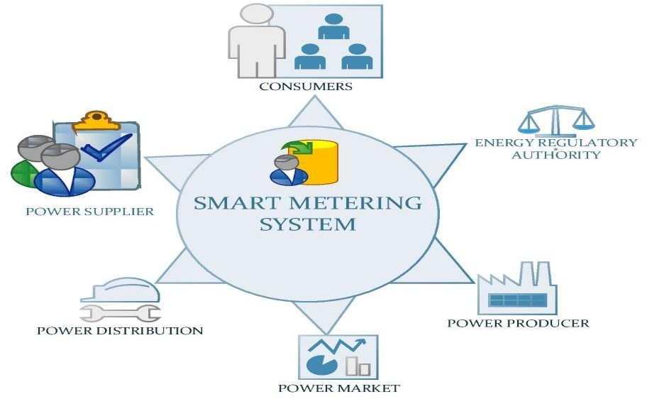

### Benefits of Smart Metering 1. Convenience

### The integration of IoT and V2X communication into vehicles offers a wide range of benefits, including:

### Enhanced Road Safety: Real-time data sharing reduces accidents by warning drivers of potential hazards like

### sudden braking or approaching emergency vehicles.

### Traffic Efficiency: Adaptive traffic signals and smart routing reduce congestion and travel time.

### Environmental Impact: Optimized driving patterns and reduced idling lead to lower emissions and fuel consumption.

### Autonomous Driving: V2X is a critical enabler of self-driving vehicles by providing external data inputs

### for safer navigation.

### Improved User Experience: Personalized infotainment, remote diagnostics, and predictive maintenance enhance

### driver comfort and convenience

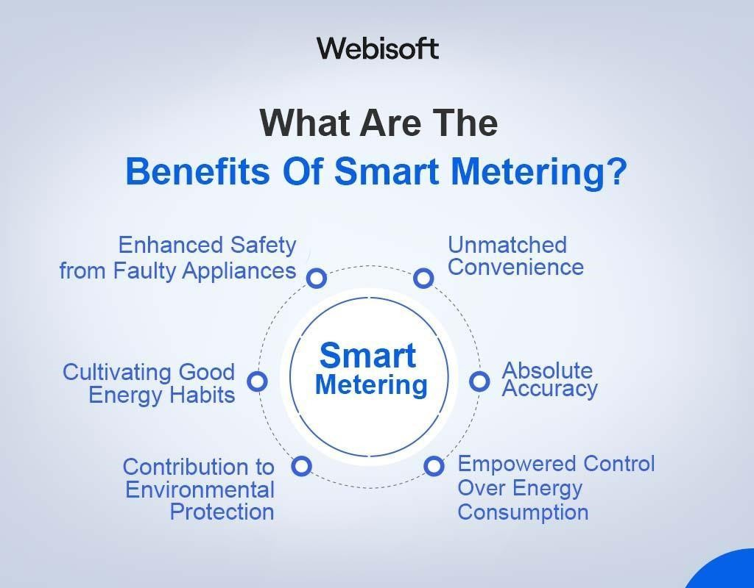

### Challenges and Considerations

Despite its promising potential, the deployment of connected vehicle technologies faces several challenges:

Cybersecurity Risks: Connectivity introduces vulnerabilities to hacking and unauthorized access.

Data Privacy: Continuous data collection raises concerns about user privacy and data ownership.

Infrastructure Requirements: Significant investments are needed to upgrade roadways and communication

networks to support V2X systems.

Standardization: Lack of global standards for V2X protocols can hinder interoperability between vehicles from different manufacturers.

Latency and Reliability: Real-time communication demands ultra-low latency and highly reliable networks,

especially for safety-critical applications.

**futures**

The future of connected vehicles lies in the continued advancement of 5G, edge computing, and AI. As

technologies mature, we can expect:

Widespread Adoption of Autonomous Vehicles: With robust V2X frameworks, fully autonomous vehicles will

become more viable and safer.

Smart Cities Integration: Connected vehicles will play a key role in smart city ecosystems, contributing to

efficient urban mobility.

Improved Policy and Regulation: Governments and industry bodies will develop frameworks to support

innovation while ensuring safety and compliance.

Global Interoperability: Efforts to standardize V2X technologies will enable seamless communication across

borders and manufacturers.

## Conclusion

## Connected vehicles, empowered by IoT and V2X communication technologies, represent a major shift in the automotive and transportation industries. By enabling vehicles to communicate with each other and their surroundings, these innovations promise to enhance safety, reduce traffic congestion, and pave the way for autonomous mobility. While there are significant challenges—such as cybersecurity, infrastructure demands, and standardization—the potential benefits far outweigh the obstacles. As technology evolves and collaboration between governments, industries, and researchers continues, connected vehicles will become a cornerstone of future smart transportation systems. This transition marks a critical step toward a safer, more efficient, and intelligent mobility landscape.

## References

S. Kumar and P. Rawat, “IoT-based smart metering system for energy efficiency and demand-side management,” *IEEE Transactions on Smart Grid*, vol. 12, no. 3, pp. 2451–2463, 2022.

J. Smith, R. Patel, and M. Zhou, “Real-time energy monitoring using IoT-enabled smart meters,” *Sensors*, vol. 22, no. 8, p. 3157, 2022.

L. Chen and Y. Wang, “Secure and scalable IoT architecture for smart metering applications,” *Journal of Applied Electrical, Science, & Technology*, vol. 5, no. 2, pp. 45–50, 2023.

D. Brown and T. Johnson, “AI-driven predictive analytics for smart metering and energy optimization,”

*IEEE Transactions on Industrial Informatics*, vol. 18, no. 7, pp. 5789–5798, 2023.

M. Al-Fuqaha and A. M. Quwaider, “Blockchain-based energy trading and smart metering: A decentralized  approach,” *IEEE Pervasive Computing*, vol. 21, no. 4, pp. 85–90, 2022.

E. Fernandez and R. Liu, “The role of machine learning in enhancing smart metering systems for energy efficiency,” *IEEE Transactions on Smart Grid*, vol. 14, no. 1, pp. 132–145, 2023.